Teacher:

Name:



**YEAR 11 SEMESTER ONE 2008**

**HUMAN BIOLOGY EXAMINATION**

***SECTION B***

**Section A: Multiple Choice – 40 Questions – 40%**

Answer the multiple choice questions by **CROSSING** out the letter of your choice on the answer sheet provided.

**Section B: Short Answers – 9 Questions – 40%**

Answer the questions in the spaces provided. Answers are to be in **BLUE** or **BLACK** biro.

**Section C: Extended Answers – 2 Questions – 20%**

Answer all parts of question 1 **or** 2 and all parts of question 3 **or** 4. Write the answer on the lined paper provided.

**SECTION B: - Short Answer**

Section A = / 40

Section B = / 110 X 0.364 = /40

Section C = /20

**Total /100**

You must answer all the questions in Section B in the spaces provided. Answers must be in **BLUE or BLACK PEN**, diagrams are to be in pencil and clearly labelled.

**Question 41**

(a) Describe how the following factors affect the rate of diffusion?

***Concentration of Molecules***

_________________________________________________________________________

_________________________________________________________________________  
 _________________________________________________________________________  
 _________________________________________________________________________

***Temperature***

_________________________________________________________________________

_________________________________________________________________________

_________________________________________________________________________  
_________________________________________________________________________

(2)

(b) What are the differences between aerobic and anaerobic respiration?

***Aerobic Respiration*** _________________________________________________________________________

_________________________________________________________________________

_________________________________________________________________________

_________________________________________________________________________

***Anaerobic Respiration***

_________________________________________________________________________

_________________________________________________________________________

_________________________________________________________________________

_________________________________________________________________________

(c) Identify the organelles labelled from the following diagrams and write a major function for each of them below.

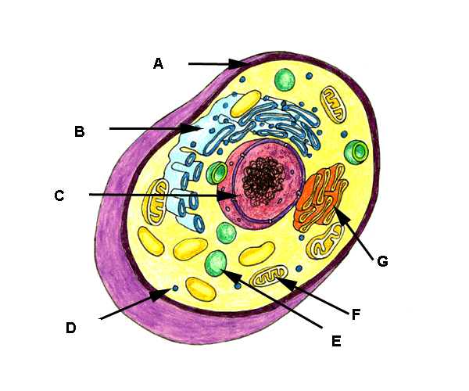

|  |  |  |
| --- | --- | --- |
|  | **STRUCTURE** | **FUNCTION** |
| **A** |  |  |
| **B** |  |  |
| **C** |  |  |
| **F** |  |  |
| **G** |  |  |

(10)

(d) Complete this equation.

C6 H12O6 + ___________________ 6CO2 + 6H20 + _____________

(4)

(e) Which type of respiration is represented by this equation?

_________________________________________________________________________

(1)

(f) In which part of the cell does the equation in (d) take place?

_________________________________________________________________________

(1)

(g) Explain how ATP is formed in the body. Use a diagram to explain you answer.

___________________________________________________________________________

___________________________________________________________________________

___________________________________________________________________________

___________________________________________________________________________

___________________________________________________________________________

___________________________________________________________________________

___________________________________________________________________________

(3)

**Question 42.**

Refer to the diagram below:

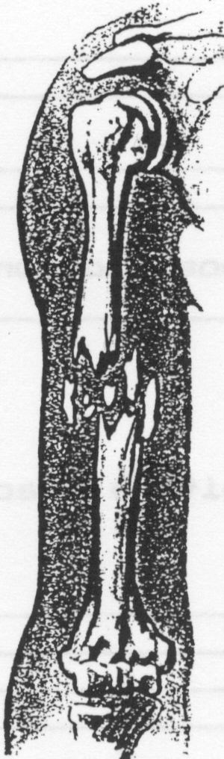

(a) Describe the type of fracture illustrated above. ____________________________

(1)

(b) Describe four main symptoms which may indicate that a fracture has occurred.

(i)_____________________________________________________________________

_______________________________________________________________________ (ii)____________________________________________________________________

______________________________________________________________________

(iii)___________________________________________________________________

______________________________________________________________________

(iv)___________________________________________________________________

______________________________________________________________________

(4)

(c) Why must a fracture be immobilised before moving the casualty?

_____________________________________________________________________________

_____________________________________________________________________________

_____________________________________________________________________________

(2)

**Question 43.**

**FIGURE 1 – Skeleton and skeletal features of a quadruped primate, gorilla and human.**

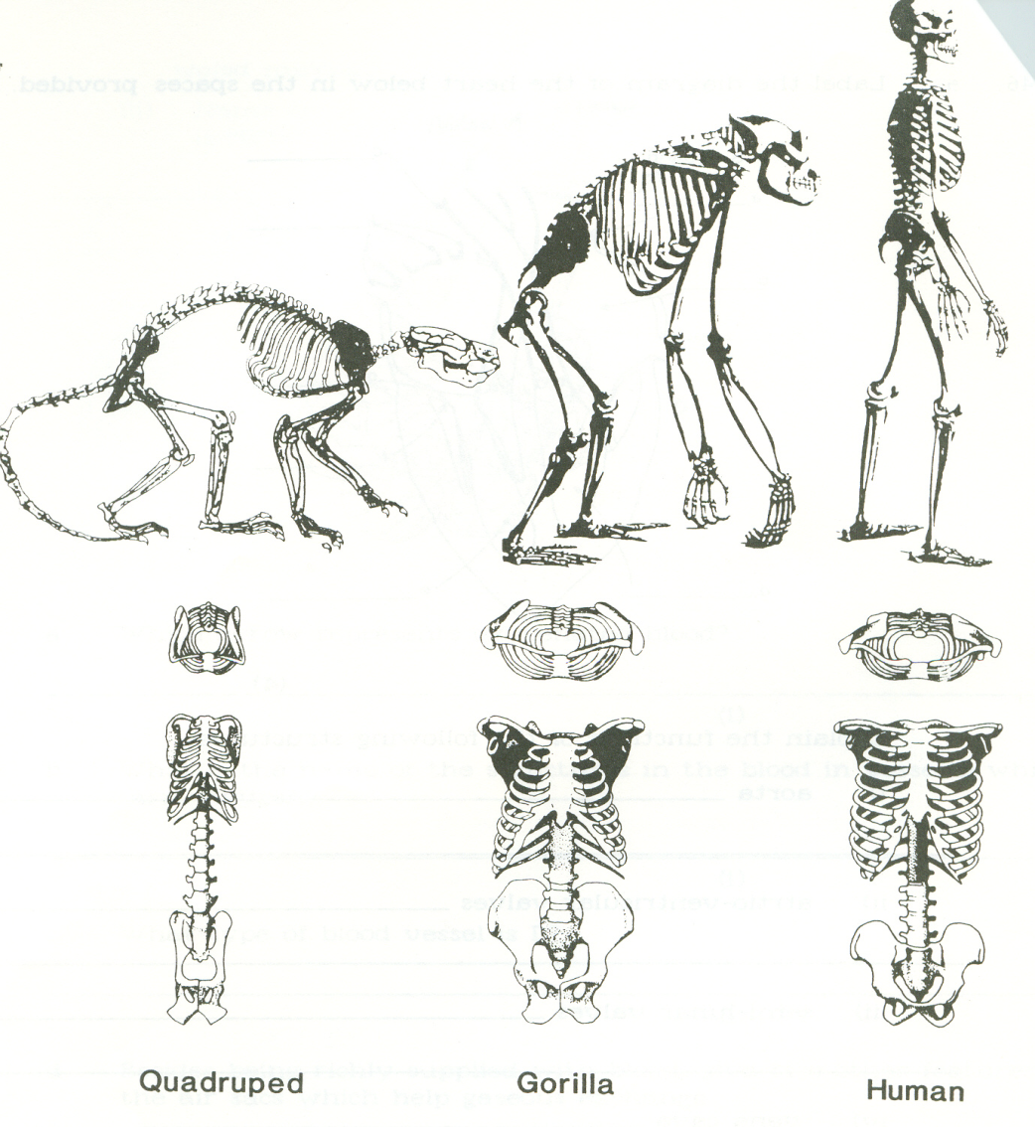

Examine the illustrations of the full skeleton and skeletal features belonging to a quadrupedal primate, gorilla and human in Figure 1 above.

(a) State **ONE** feature of the quadrupedal skeleton illustrated in Figure 1 which is suited for quadrupedal walking and **explain** how it assists this mode of locomotion.

_________________________________________________________________________________________________________________________________________________________________________________________________________________________________________________________________________________ (3)

(b) Describe **TWO** s***tructural*** features evident in Figure 1 which account for the fact that the ***gorilla*** is not able to walk bipedally for extended periods of time.

(i)____________________________________________________________________________________________________________________________________________________________________________________

(ii)___________________________________________________________________________________________________________________________________________________________________________________

(4)

(c) Describe **TWO** ***structural*** features evident in Figure 1 which enable ***humans*** to carry out bipedalism.

(i)____________________________________________________________________________________________________________________________________________________________________________________

(ii)___________________________________________________________________________________________________________________________________________________________________________________

(4)

**FIGURE 2 – PRIMATE HANDS**

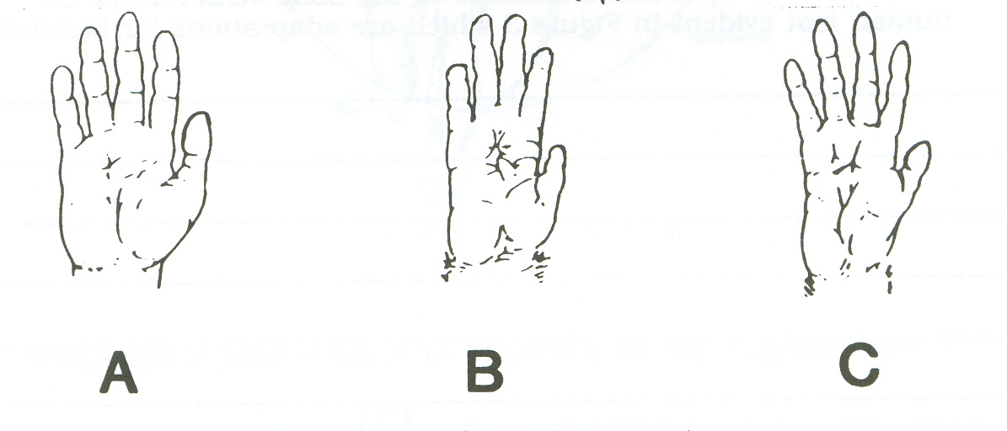

(d) Which of the hands illustrated in Figure 2 is not suited for brachiation? Give three reasons to justify your answer.

1. _______________________________________________________________________________________________________________________________________________________________________
2. ________________________________________________________________________________________________________________________________________________________________________
3. ________________________________________________________________________________________________________________________________________________________________________ (4)

**Question 44. Use the following illustrations to answer the questions on the following page.**

**NB - The arcs on the diagram represent the range of motion for each joint.**

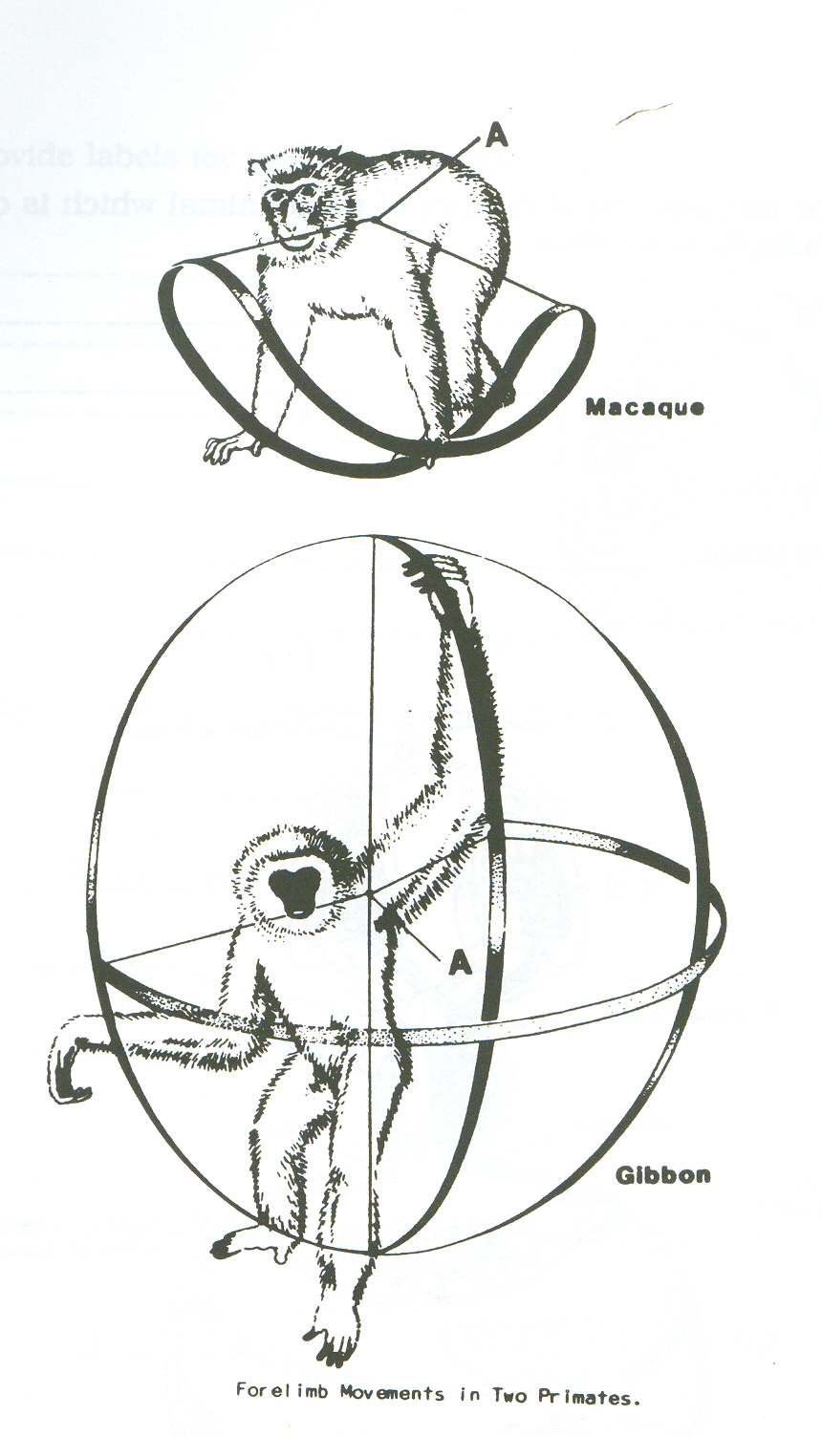

(a) What type of joint is the joint labelled A on the diagram above?

__________________________________________________________________________

(1)

(b) Both of these animals belong to the same sub-order. What is it?

__________________________________________________________________________

(1)

(c) Give the family name for each animal.

Gibbon____________________________________________________________________

Macaque___________________________________________________________________

(2)

1. Explain with reference to structure, why a gibbon can brachiate whereas a macaque uses quadrupedal locomotion?

_________________________________________________________________________________

_________________________________________________________________________________

_________________________________________________________________________________

_________________________________________________________________________________

_________________________________________________________________________________

_________________________________________________________________________________

_________________________________________________________________________________

(4)

**Question 45.**

|  |  |  |  |
| --- | --- | --- | --- |
| **SUBSTANCE** | **NORMAL CELL CONTENTS (mg/mL)** | **SOLUTION 1**  **(mg/mL)** | **SOLUTION 2**  **(mg/mL)** |
| ***Sodium Ions*** | 70.0 | 30.0 | 100.0 |
| ***Magnesium Ions*** | 0.003 | 0.005 | 0.001 |
| ***Potassium Ions*** | 420.0 | 400.0 | 500.0 |
| ***Calcium Ions*** | 1.2 | 0.6 | 10.0 |
| ***Chlorine Ions*** | 510.0 | 600.0 | 100.0 |
| **Total** | **1001.203** | **1030.205** | **710.001** |

(a) If the cell was placed in solution 1, describe the nett movement of water and explain why this would occur?

________________________________________________________________________________

________________________________________________________________________________

________________________________________________________________________________

(3)

(b) If the cell was placed in solution 2, describe the nett movement of Sodium and explain why this would occur?

________________________________________________________________________________

________________________________________________________________________________

________________________________________________________________________________

(3)

(c) When the cell was placed in solution 2, its chlorine level remained constant at 510.0mg/mL. Assuming that the cell membrane was permeable to chlorine, describe in detail how the cell achieved this.

________________________________________________________________________________

________________________________________________________________________________

________________________________________________________________________________

(3)

**Question 46.**

1. Name the following tissue types and a specific location in the body where you would find each tissue. **Use the table on the following page**.

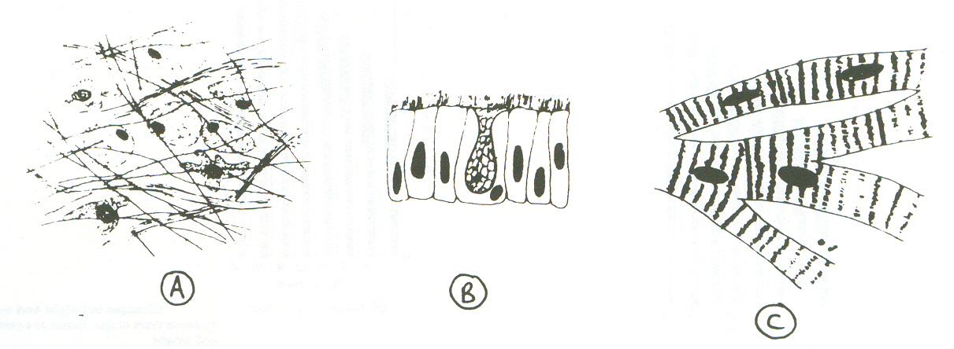

C

B

A

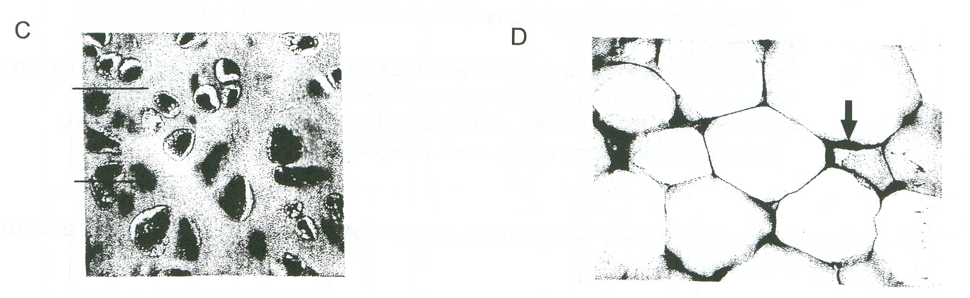

E

D

|  |  |  |
| --- | --- | --- |
| **TISSUE** | **NAME SPECIFIC TISSUE** | **LOCATION FOUND IN BODY** |
| **A** |  |  |
| **B** |  |  |
| **C** |  |  |
| **D** |  |  |
| **E** |  |  |

(10)

(b) Complete the following:

(i) What is a ‘carcinogen’? Give two examples to support your answer.

_____________________________________________________________________________

_____________________________________________________________________________

**_____________________________________________________________________________**

(ii) Explain how carcinogens can cause cancer. (3)

_____________________________________________________________________________

_____________________________________________________________________________

(2)

1. Describe somepositive steps that you can take to reduce the risk of cancer later in life.

**_______________________________________________________________________________**

**_______________________________________________________________________________**

**_______________________________________________________________________________**

**_______________________________________________________________________________**

**_______________________________________________________________________________**

**_______________________________________________________________________________**

**(3)**

**Question 47.**

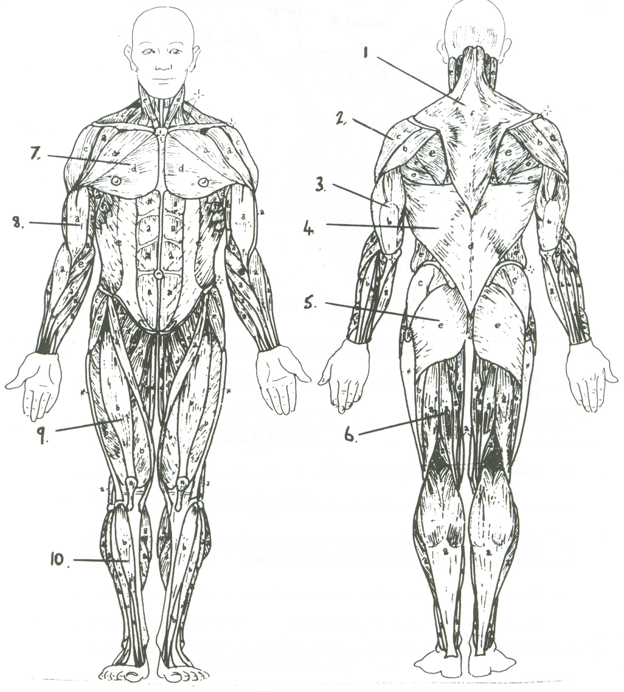

Label the following muscles from the diagram above.

|  |  |
| --- | --- |
| **Number** | **Muscle Name** |
| 2 |  |
| 5 |  |
| 6 |  |
| 9 |  |
| 10 |  |

(5)

**Question 48.**  The diagram below shows the main muscle groups associated with the upper limb.

(a)

(i) Which muscle groups would raise the humerus as shown by the arrow?

____________________________________________________________________

____________________________________________________________________

(ii) Which joint would be involved in this movement?

____________________________________________________________________

(iii) What type of joint is this?

____________________________________________________________________

(iv) Why do we have such great flexibility at this joint?

____________________________________________________________________

____________________________________________________________________

(4)

(b) The biceps muscle has two heads. Describe where the origins are.

_______________________________________________________________________________

_______________________________________________________________________________

_______________________________________________________________________________

(2)

(c) Complete the following table by drawing the joint and providing one example of where it is found in the body.

|  |  |  |
| --- | --- | --- |
| **TYPE** | **DIAGRAM** | **EXAMPLE** |
| **GLIDING JOINT** |  |  |
| **SADDLE JOINT** |  |  |

(6)

(d) Describe how the knee is structure to cope with the range of movements and stresses required of it. Use a diagram to support your answer.

**_______________________________________________________________________________**

**_______________________________________________________________________________**

**_______________________________________________________________________________**

**_______________________________________________________________________________**

**_______________________________________________________________________________**

**_______________________________________________________________________________**

**_______________________________________________________________________________**

**_______________________________________________________________________________**

**_______________________________________________________________________________**

**_______________________________________________________________________________**

**_______________________________________________________________________________**

**_______________________________________________________________________________**

**_______________________________________________________________________________**

(4)

**Question 49.**

Draw the following diagrams to show their respective phases of Mitosis and give an explanation for each.

(9)

INTERPHASE

____________________________________________________________________________________________________________________________________________________________________________________________________________

METAPHASE

____________________________________________________________________________________________________________________________________________________________________________________________________________

TELOPHASE

____________________________________________________________________________________________________________________________________________________________________________________________________________